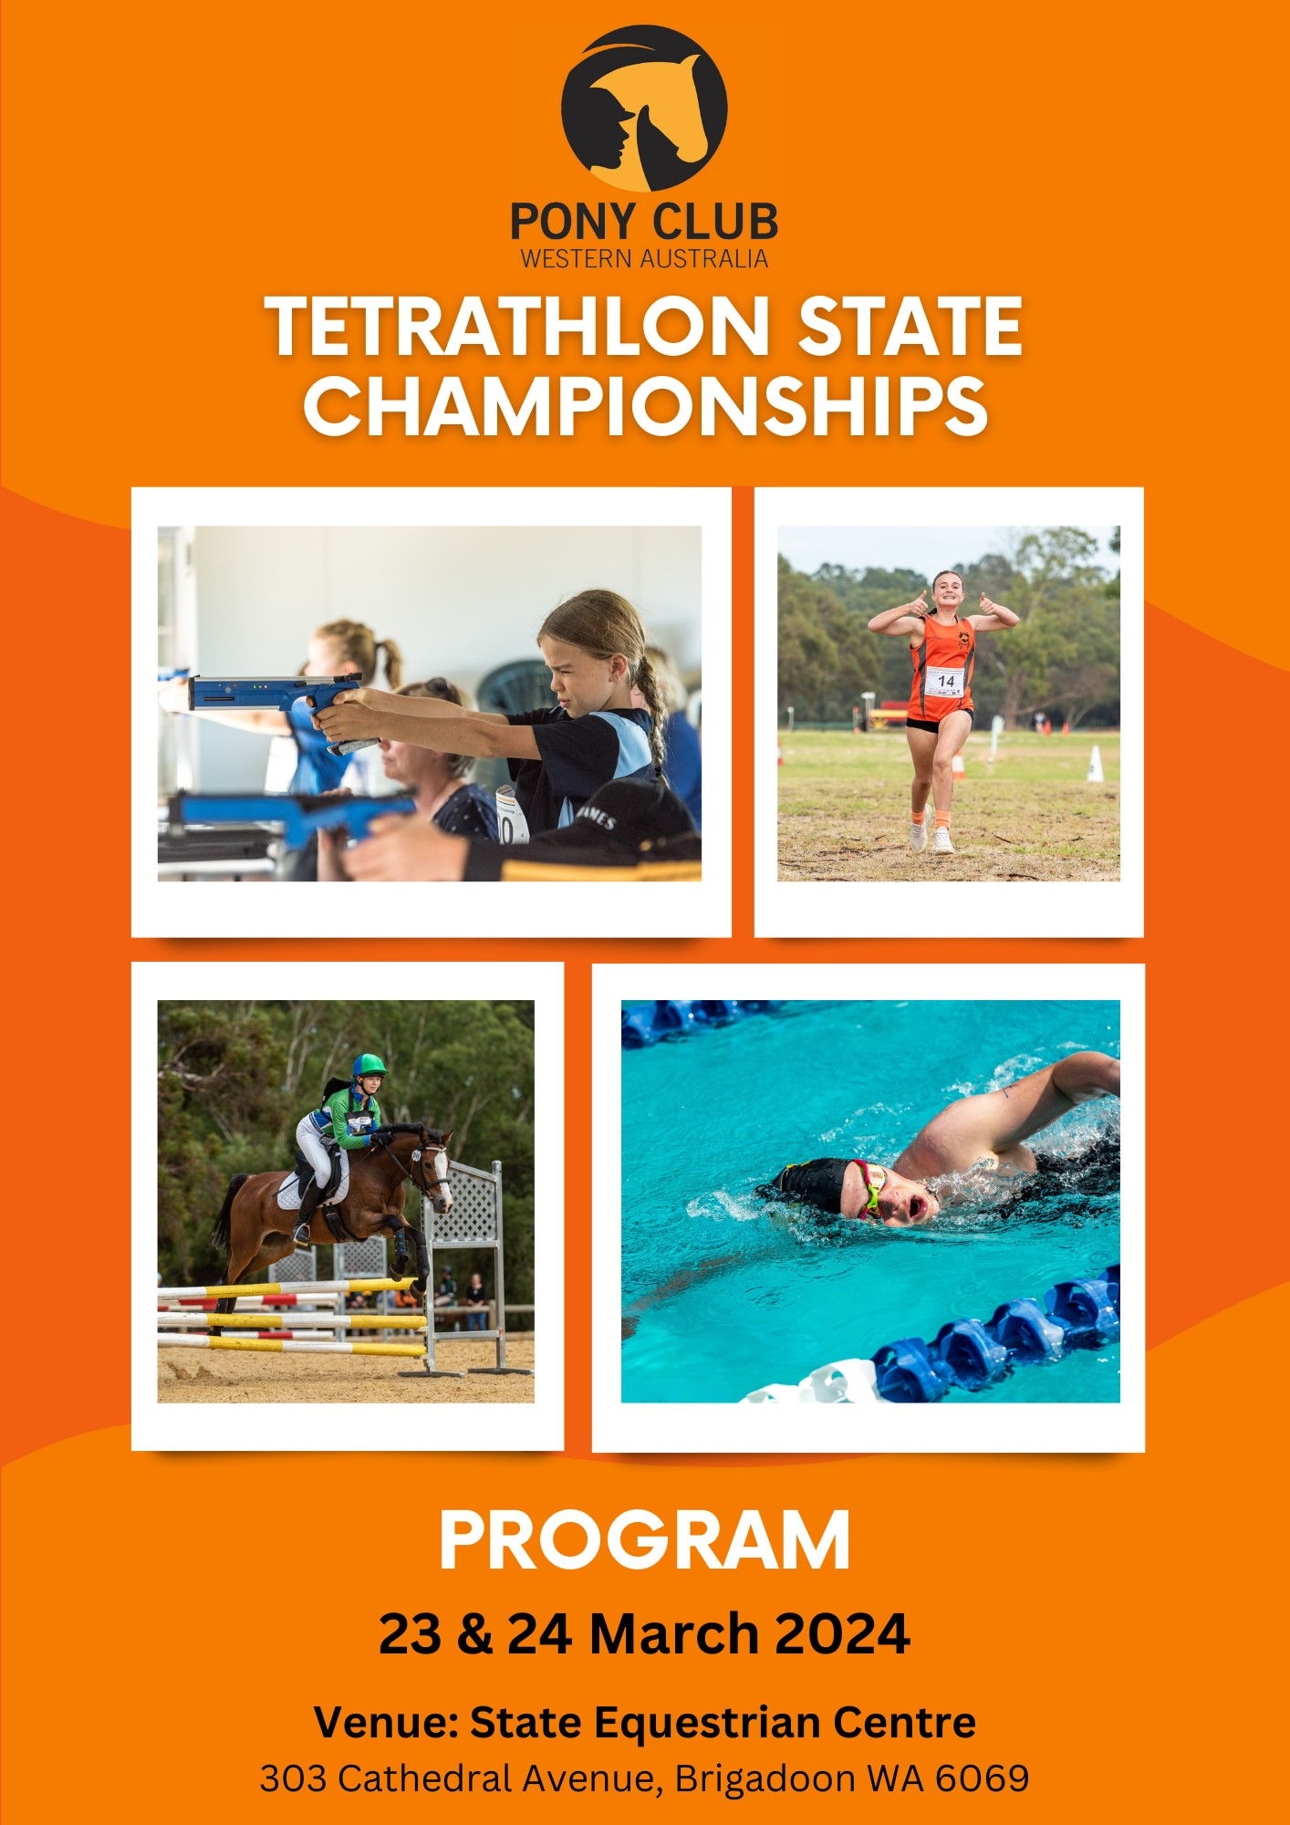
CLUB WA STATE TETRATHLON CHAMPIONSHIPS 2024
PONY CLUB WA STATE TETRATHLON COMMITTEE
Lisa Maxwell (Chair) | Dawn Banner (Secretary) | Sarah Wiese
Julie Frantom | Bill Wiese | Sally Cox
Donna Black | Nikita Mawhirt | Campbell Black
Bec Halbert

CHAMPIONSHIP OFFICIALS
Event Secretaries Lisa Maxwell and Sarah Wiese
Technical Delegate Deb Ware
Run Steward Dawn Banner
Shoot Steward Jane Steele
Swim Steward Julie Frantom
Swim Starter Bec Halbert6
Ride Steward Sally Cox
Ride Judges Judy Rose and Wendy Boyle
Course Designer M’Liss Henry
Chief Gear Checker Dianne Ould
Scorers Sarah Wiese and Bec Halbert
Social Media Donna Black

Vets On Call
Belvoir Equine Hospital
Lot 158 West Swan Road, Belhus 6069
Phone: 08 9296 6666

First Aid
Medic Aid
Keith Ferguson 0427 987 597

Photographer
Colin White Photography
http://colinwhitephotography.com.au/
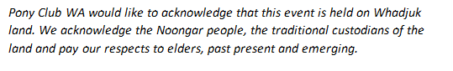

EVENT INFORMATION

LOCATION: State Equestrian Centre
303 Cathedral Avenue, Brigadoon WA
WHEN: 23 and 24 March 2024

PHASE SCHEDULE & LOCATION
Running Phase – Saturday  State Equestrian Centre  Swan Valley Fields  Cross Country Course  Course open Friday – 4 pm.  Helper Briefing: 8:00 am at Run start line  Saturday 8:30 am – 9:40am | Shooting Phase – Saturday  Swan Valley Pony Club  Pony Club Storage Shed  7m & 10m 1pm – 3:30 pm  Helper Briefing: 12:30 pm
Swimming Phase – Saturday  La Salle Swimming Pool  5 La Salle Avenue, Middle Swan  Helper Briefing: 10:30 am at the Pool  Saturday 11 am – 12noom | Riding Phase – Sunday  State Equestrian Centre  Swan Fields – in front of the Swan Valley Clubrooms  Ride Course walk Saturday from 2 pm onwards  Helper Briefing: 7:30 am Swan Fields GP Arena  Sunday 8:00 am – 12:45 pm

GENERAL INFORMATION
EVENT RULES
This Event is run under the following rules:
REFERENCE DOCUMENTS
The Pony Club WA State Tetrathlon Championship is run in accordance with the following:
Pony Club WA Tetrathlon Reference Document 2024
Pony Club Australia National Tetrathlon Rules
Pony Club WA State Competition General Regulations
Pony Club Australia National Gear Rules
Pony Club WA Appendixes to support the Pony Club Australia National Gear Rules
All competitors, parent helpers, officials, and volunteers must be familiar with these documents.

Appeals Committee
Lisa Maxwell | Sarah Wiese
M’liss Henry | Tanya Appleby
Judy Rose

As per the State Competition General Regulations:
25.1 The Appeals Committee is responsible for:
i dealing with protests against decisions of the Technical Expert; and
ii dealing with cases of infringements of any rules for which the Technical Expert is not responsible.
25.2 In carrying out its responsibilities the Appeals Committee may seek the advice of any person deemed appropriate and necessary to assist them in reaching a decision.
25.3 The composition of the Appeals Committee for each state competition shall be determined by the State Sport Committee or organising Taskforce, providing that the Appeals Committee shall consist of at least three people, all of whom have sufficient knowledge of the rules and processes relevant to Pony Club WA and that sport.
25.4 The following persons may not serve as a member of the Appeals Committee:
i. the Technical Expert that made the decision that is the subject of the relevant protest and appeal;
ii. any judges of the competition/class pertaining to the protest; and
iii. any person with a conflict of interest
PRESENTATIONS
Presentations will be completed as soon as practicable after the conclusion of the event.
We would appreciate as much help as possible to pack away the Ridden Phase jumps.
All competitors are to attend in their pony club riding uniform. Cross-country shirts are acceptable. Formal uniform is not required.
FOOD
The Canteen at Swan Valley Horse and Pony Club is open on Saturday and Sunday to provide a range of meals, snacks, and hot and cold drinks. The canteen will be open 8 am – 2 pm both days. Pay with cash or EFT available after 9 am.
A two-course meal was available to pre-order for dinner on Saturday night.

PONY CLUB WA – NO DOG POLICY
This is a Pony Club WA event, and the policy of NO DOGS will be strictly adhered to. Failure to abide by this policy may result in the elimination of rider(s). Assistance animals approved by the Department of Local Government; Sport & Cultural Industries are exempt from this rule.
Persons with an Assistance Animal may be requested to provide their approval documentation.

CAMPING AND YARDS
Yards are available on a first-come-first-served basis. Please put your manure and hay in the manure pits provided, do not leave it in heavy unmanageable bags or dump it under trees as this will kill the native trees. Please remove all hay from yards, fill in any holes and leave yards as you would be happy to find them.
Please leave your camping area clean and tidy. Hot showers are available. Place all rubbish in any of the Sulo bins located around the grounds. Containers for Change recycling bags are also provided around the grounds. Please support Pony Club WA in being environmentally friendly and ensure you only place recyclable containers in these recycling containers.
COVID-19 EVENT GUIDELINES & REFUND POLICY
Government guidelines concerning Covid-19 restrictions and precautions will be followed.
If you are having flu like symptoms and are unsure if you have Covid-19, please do not attend the event.
A refund may be granted if you:
• test positive for Covid-19 and must isolate;
• are showing symptoms;
• are the carer of someone in isolation;
Members requesting a refund should provide supporting evidence to sports@ponyclubwa.asn.au such as a medical certificate, PCR test result, photo of RAT result, text or email from Health Authorities, or other evidence confirming Covid-19 or need to isolate.
Refunds must be requested within 7 days of the event.
Refunds may be subject to a $20 administration fee.
BEFORE DEPARTING THE GROUNDS
Please put your manure and hay in the manure pits provided, do not leave it in heavy unmanageable bags or dump it under trees as this will kill the native trees. Please fill in any holes and leave yards as you would be happy to find them.
Please leave your camping area clean and tidy. Place all rubbish in the green Sulo bins provided.

EVENT SPONSORS
Many thanks to our sponsors and supporters of the Pony Club WA State Tetrathlon Championship 2024
A heartfelt thank you to our Officials, Volunteers and Supporters

Trade stands
PIMP MY PONY
Saturday & Sunday

CLASSES
For all classes the age of the Rider is as at 1 January 2024.
CHAMPIONSHIP CLASSES | ENTRANTS | GENDER
Champ 105cm | 2 | Female
Champ 95cm | 3 | Female
Champ 95cm | 3 | Male
Champ 85cm 10-12 | 0 | Female
Champ 85cm 13-16 | 1 | Female
Champ 85cm 13-16 | 0 | Male
Champ 85cm 17-24 | 2 | Female
Champ 85cm 17-24 | 1 | Male
Champ 70cm 9-12 | 4 | Female
Champ 70cm 13-24 | 7 | Female
Champ 70cm 13-24 | 0 | Male
Champ 60cm 8-12 | 8 | Female
Champ 60cm 13-24 | 8 | Female
Champ 60cm 13-24 | 1 | Male
Champ 45cm 8-12 | 9 | Female
Champ 45cm 11-12 | 0 | Female
Champ 45cm 11-12 | 0 | Male
Champ 45cm 13-24 | 4 | Female
Open Rider | 3 | Female

DRAW
Championship 105cm & 95cm Sponsored by Anitone
Class | Class Name | Team | No | Age | Rider Name | Horse Name | Club | Team Name | Run | Swim | Shoot | Ride
 |  |  |  |  |  |  |  |  | Sat | Sat | Sat | Sun
11 | 105cm 12-24 | 1 | 1 | 17 | Isabelle Cox | Counter Offer | Esperance | Esp/K River/Gidgie/Busseltn | 8.30 | 11.30 | 1.00 | 8.00
11 | 105cm 12-24 | 2 | 2 | 16 | Caitlin Worth | Fingers Crossed | Wallangarra | Wallangarra/Swan Valley | 8.31 | 11.10 | 1.10 | 8.03
10 | 95cm 11-24 | 2 | 3 | 21 | Gabby Wells | Balmax | Wallangarra | Wallangarra/Swan Valley | 8.32 | 11.25 | 1.10 | 8.33
10 | 95cm 11-24 | 2 | 4 | 16 | Campbell Black | Missy | Wallangarra | Wallangarra/Swan Valley | 8.33 | 11.30 | 1.10 | 8.36
10 | 95cm 11-24 | 3 | 5 | 22 | Bill Wiese | Three Votes | Dryandra | Dryandra/Albany | 8.34 | 11.15 | 1.20 | 8.39
10 | 95cm 11-24 | 3 | 6 | 19 | Emma Wiese | Valentino Man | Dryandra | Dryandra/Albany | 8.35 | 11.25 | 1.20 | 8.42
10 | 95cm 11-24 | 3 | 7 | 21 | Dan Wiese | Biara Flyer | Dryandra | Dryandra/Albany | 8.36 | 11.30 | 1.20 | 8.45
10 | 95cm 11-24 | 1 | 8 | 16 | Felicity Ericsson | Royal Prestige | King River | Esp/K River/Gidgie/Busseltn | 8.37 | 11.15 | 1.00 | 8.30
16 | 95cm Open |  | 9 | 29 | Shannon Bray | Benito |  |  | 9.10 | 11.47 | 3.20 | 8.33

Championship 85cm
Class | Class Name | Team | No | Age | Rider Name | Horse Name | Club | Team Name | Run | Swim | Shoot | Ride
 |  |  |  |  |  |  |  |  | Sat | Sat | Sat | Sun
9 | 85cm 17-24 | 1 | 10 | 20 | Kaitlyn Brown | Mellandra Touch of Class | Busselton | Esp/K River/Gidgie/Busseltn | 8.38 | 11.10 | 1.00 | 9.10
9 | 85cm 17-24 | 1 | 11 | 21 | Ryan Frantom | Newhope Sparks Fly | Gidgegannup | Esp/K River/Gidgie/Busseltn | 8.39 | 11.20 | 1.00 | 9.13
9 | 85cm 17-24 | 3 | 12 | 17 | Mikayla Owen | Rebel Flight | Albany | Dryandra/Albany | 8.40 | 11.05 | 1.20 | 9.19
Championship 70cm sponsored by Thompson & Redwood

Class | Class Name | Team | No | Age | Rider Name | Horse Name | Club | Team Name | Run | Swim | Shoot | Ride
 |  |  |  |  |  |  |  |  | Sat | Sat | Sat | Sun
6 | 70cm 13-24 | 4 | 14 | 14 | Emmi Kneale | Miss Miracle | Serpentine | Serpentine | 8.42 | 11.00 | 1.30 | 9.45
6 | 70cm 13-24 | 4 | 15 | 13 | Stella Brown | Brayside Forever After | Serpentine | Serpentine | 8.43 | 11.20 | 1.30 | 9.48
5 | 70cm 9-12 | 4 | 16 | 11 | Sophie Mosey | Gordon Park Capriccio | Serpentine | Serpentine | 9.11 | 11.35 | 2.30 | 9.51
5 | 70cm 9-12 | 4 | 17 | 12 | Zara Officer | Limehill Royal Jester | Serpentine | Serpentine | 9.12 | 11.44 | 2.30 | 9.54
6 | 70cm 13-24 | 5 | 18 | 13 | Imogen O'Hehir | Luvash Cassie | Dardanup | Dardanup/Beverley | 8.44 | 11.00 | 1.30 | 9.57
6 | 70cm 13-24 | 5 | 19 | 14 | Ivy Colebrook | Pixie | Dardanup | Dardanup/Beverley | 8.45 | 11.00 | 1.30 | 10.00
5 | 70cm 9-12 | 5 | 20 | 11 | Ruth Elsegood | Karlinda Gusimmons | Beverley | Dardanup/Beverley | 9.13 | 11.47 | 2.30 | 10.03
6 | 70cm 13-24 | 6 | 21 | 17 | Zarli Curtis | Protectable | Albany | Murray/Albany | 8.46 | 11.05 | 1.40 | 10.06
6 | 70cm 13-24 | 6 | 22 | 15 | Willow Hawkins | Ragnar Lothbrok | Murray | Murray/Albany | 8.47 | 11.05 | 1.40 | 10.09
6 | 70cm 13-24 | 6 | 23 | 19 | Taiah Curtis | Eydis | Albany | Murray/Albany | 8.48 | 11.05 | 1.40 | 10.12
5 | 70cm 9-12 | 6 | 24 | 11 | Willow Bennett | Beelo-Bi Thoredo | Albany | Murray/Albany | 9.14 | 11.41 | 2.30 | 10.15

Championship 60cm- Community driven support from the City of Swan
Class | Class Name | Team | No | Age | Rider Name | Horse Name | Club | Team Name | Run | Swim | Shoot | Rider
 |  |  |  |  |  |  |  |  | Sat | Sat | Sat | Sun
3 | 60cm 8-12 | 7 | 25 | 10 | Seren Esposito | Beelo-Bi Golden Girl | Wanneroo | Wanneroo | 9.15 | 11.35 | 2.40 | 10.35
3 | 60cm 8-12 | 7 | 26 | 12 | Molly Hill | Sassy but Classy | Wanneroo | Wanneroo | 9.16 | 11.35 | 2.40 | 10.38
3 | 60cm 8-12 | 7 | 27 | 11 | Sara Scott | Salisbury Magic Affair | Wanneroo | Wanneroo | 9.17 | 11.47 | 2.40 | 10.41
3 | 60cm 8-12 | 7 | 28 | 9 | Ruby Neame-Luty | Wendamar Nia | Wanneroo | Wanneroo | 9.18 | 11.35 | 2.40 | 10.44
4 | 60cm 13-24 | 8 | 29 | 19 | Hannah Steinhoff | Willowie Wild Child | Albany | Albany | 8.49 | 11.00 | 1.40 | 10.47
4 | 60cm 13-24 | 8 | 30 | 22 | Becky Stride | Makuta | Albany | Albany | 8.50 | 11.05 | 1.40 | 10.50
3 | 60cm 8-12 | 8 | 31 | 12 | Koa Doyle | Maddilyn | Albany | Albany | 9.19 | 11.41 | 2.50 | 10.53
4 | 60cm 13-24 | 9 | 32 | 19 | Tameaka Smith | Clare Downs Gandalf | Busselton | Busselton/Horsemans | 8.51 | 11.20 | 1.50 | 10.56
4 | 60cm 13-24 | 9 | 33 | 13 | Sienna McKimm | Rio Cambria Integrity | Busselton | Busselton/Horsemans | 8.52 | 11.10 | 1.50 | 10.59
3 | 60cm 8-12 | 9 | 34 | 11 | Elaria Atheis | Wildwood Beyond Paradise | Horsemans | Busselton/Horsemans | 9.20 | 11.41 | 2.50 | 11.02
4 | 60cm 13-24 | 10 | 35 | 13 | Jace Budd-Doyle | Chariles Playinacre | Eastern Hills | Eastern Hills/Dardanup | 8.53 | 11.25 | 1.50 | 11.05
4 | 60cm 13-24 | 10 | 36 | 13 | Jasmine Fisher | Maraahn El Shamae | Dardanup | Eastern Hills/Dardanup | 8.54 | 11.10 | 1.50 | 11.08
3 | 60cm 8-12 | 10 | 37 | 11 | Lexi O'Neill | Tiaja Park Foxy | Dardanup | Eastern Hills/Dardanup | 9.21 | 11.38 | 2.50 | 11.11
4 | 60cm 13-24 | 11 | 38 | 18 | Kate Banner | Over the Rainbow | Peel | Peel/Beverley/Serpentine | 8.55 | 11.30 | 2.00 | 11.14
4 | 60cm 13-24 | 11 | 39 | 18 | Emily Maxwell | Eddie | Beverley | Peel/Beverley/Serpentine | 8.56 | 11.10 | 2.00 | 11.17
4 | 60cm 13-24 | 11 | 40 | 18 | Sophie Appleby | Penley Marco Polo | Serpentine | Peel/Beverley/Serpentine | 8.58 | 11.15 | 2.00 | 11.20
3 | 60cm 8-12 | 11 | 41 | 12 | Marlie Helliwell | Bralgon Hottshott | Serpentine | Peel/Beverley/Serpentine | 9.22 | 11.41 | 2.50 | 11.23
13 | 60cm Open |  | 42 | 42 | Alicia O'Hehir | Outlaw King | Dardanup |  | 9.23 | 11.35 | 3.20 | 11.26
13 | 60cm Open |  | 43 | 25 | Brooke Bishop | Livanto | Dardanup |  | 9.24 | 11.47 | 3.20 | 11.29
Championship 45cm sponsored by our partners Healthway
Class | Class Name | Team | No. | Age | Rider Name | Horse Name | Club | Team Name | Run | Swim | Shoot | Ride
 |  |  |  |  |  |  |  |  | Sat | Sat | Sat | Sun
1 | 45cm 8-12 | 12 | 44 | 11 | Sienna Balinski | Tamblyn Park Image | Dardanup | Dardanup | 9.25 | 11.44 | 3.00 | 12.00
1 | 45cm 8-12 | 12 | 45 | 10 | Pippa O'Neill | Jack | Dardanup | Dardanup | 9.26 | 11.38 | 3.00 | 12.03
1 | 45cm 8-12 | 12 | 46 | 11 | Alice Colebrook | Celestine Winston | Dardanup | Dardanup | 9.27 | 11.38 | 3.00 | 12.06
1 | 45cm 8-12 | 12 | 47 | 11 | Kate Watkins | Applewood Classic Deluxe | Dardanup | Dardanup | 9.28 | 11.44 | 3.00 | 12.09
2 | 45cm 13-24 | 13 | 48 | 15 | Tracey Jooste | Hunter's Choice | Horsemans | Horsemans/Kellerberrin | 8.57 | 11.20 | 2.00 | 12.12
2 | 45cm 13-24 | 13 | 49 | 13 | Amelia Speed | Secret | Horsemans | Horsemans/Kellerberrin | 8.59 | 11.15 | 2.10 | 12.15
1 | 45cm 8-12 | 13 | 50 | 8 | Florence Wilson | Paddy | Kellerberrin | Horsemans/Kellerberrin | 9.29 | 11.47 | 3.10 | 12.18
2 | 45cm 13-24 | 14 | 51 | 13 | Hannah Rose | Dusty | Central Midlands | Central Midlands/Wallangarra | 9.00 | 11.00 | 2.10 | 12.21
1 | 45cm 8-12 | 14 | 52 | 11 | Kaylee Thompson | Comanche | Wallangarra | Central Midlands/Wallangarra | 9.30 | 11.41 | 3.10 | 12.24
1 | 45cm 8-12 | 14 | 53 | 11 | Kate Berzins | Tayledras Cymry | Wallangarra | Central Midlands/Wallangarra | 9.31 | 11.44 | 3.10 | 12.27
2 | 45cm 13-24 | 15 | 54 | 13 | Sophie Tennant | Jejucha Romany Heart | Swan Valley | Swan Valley/Serpentine | 9.01 | 11.15 | 2.10 | 12.30
1 | 45cm 8-12 | 15 | 55 | 9 | Harriet Dickinson | George | Serpentine | Swan Valley/Serpentine | 9.32 | 11.38 | 3.10 | 12.33
1 | 45cm 8-12 | 15 | 56 | 12 | Bella Pearce | Bungullastud Impact | Serpentine | Swan Valley/Serpentine | 9.33 | 11.38 | 3.20 | 12.36
12 | 45cm Open |  | 57 | 49 | Linda Dorricott | HV Relago | Dardanup |  | 9.34 | 11.44 | 3.20 | 12.39

AWARDS
PONY CLUB WA CHAMPIONSHIP CLASSES
- Rosettes to 6th for individual riders. Saddle blankets for individual winners
- Rosettes to 6th for team placings. Rugs for the winning teams
Riders in the Championship Classes are eligible for the following special awards:
- Lucy Oorschot Trophy - for the female athlete with the highest combined run and swim score in the 95cm and 105cm Championship Classes
- Highest scoring shooter (7m, 10m)
- Highest scoring swimmer (100m, 200m)
- Highest scoring runner (1000m, 2000m)
- Highest scoring rider (45cm-60cm, 75cm-85cm, 95-105cm)
- Off the Track Best Performed Award
LUCY OORSCHOT TROPHY
The Lucy Oorshot Trophy is awarded in memory of one of our Tetrathlon competitors. The Trophy is awarded to the female competitor in the 95 and 105cm classes with the highest combined run and swim scores.
Tetrathlon was Lucy’s favourite event as it combined three of her favourite sports, Running, Swimming and Riding. Lucy was a member of the Western Australian Tetrathlon team that won in 2013 at the Pony Club Nationals.
OPEN RIDER CLASSES
- Rosettes to 6th for individual riders
- Saddle blankets for individual winners
STATE LEADERBOARDS
All Leaderboard enquiries are to be directed to the State Office:
membership@ponyclubwa.asn.au
Leaderboard points will be awarded as per the table below:
Championship Classes | Double Points

