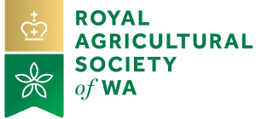

2021 PERTH ROYAL SHOW

25 SEPTEMBER – 2 OCTOBER

Additional Ticket Application

EXHIBITOR NAME:

ADDRESS:

CONTACT NAME: ………………………………………………… MOBILE NO:

EMAIL ADDRESS: …………..……………………………………………………………….

SHOW SECTION: Alpacas Cattle - Beef Cattle - Dairy
(Please tick)
Cattle - Led Steer & Heifer Dairy Goats Discover WA Dogs Horses Breed Horses in Action
Showjumping Sheep

TICKETS REQUIRED: (QUANTITY)

SAT | SUN | MON | TUE | WED | THUR | FRI | SAT
25/09/2021 | 26/09/2021 | 27/09/2021 | 28/09/2021 | 29/09/2021 | 30/09/2021 | 01/10/2021 | 02/10/2021

PERTH ROYAL SHOW ADDITIONAL TICKET: $30.00 PER DAY (includes GST)

All persons wishing to enter the Showground before 9.00am must hold a valid entry pass and will need to complete this application form.

PAYMENT TO BE MADE THROUGH PONY CLUB ENTRES

Signature:..............................................................................................................Date:..............................................................................

