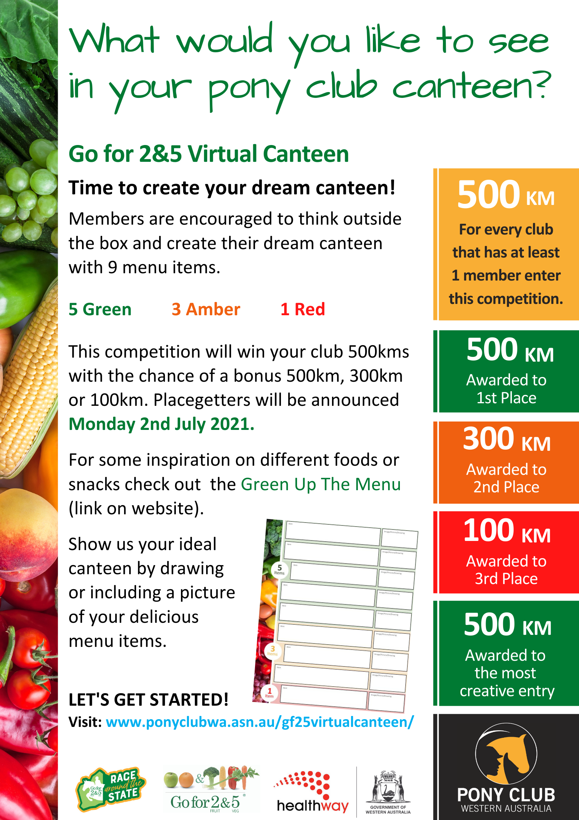

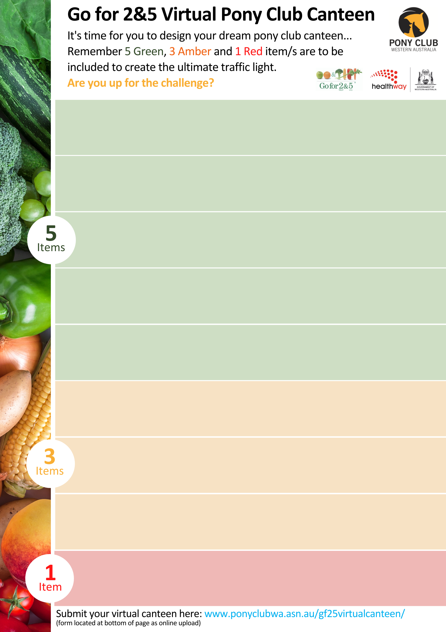

Image/Picture/Drawing

*Item*

Image/Picture/Drawing

*Item*

*Item*

Image/Picture/Drawing

*Item*

Image/Picture/Drawing

Image/Picture/Drawing

*Item*

Image/Picture/Drawing

Image/Picture/Drawing

*Item*

*Item*

Image/Picture/Drawing

*Item*

Image/Picture/Drawing

*Item*