Accidents Will Happen

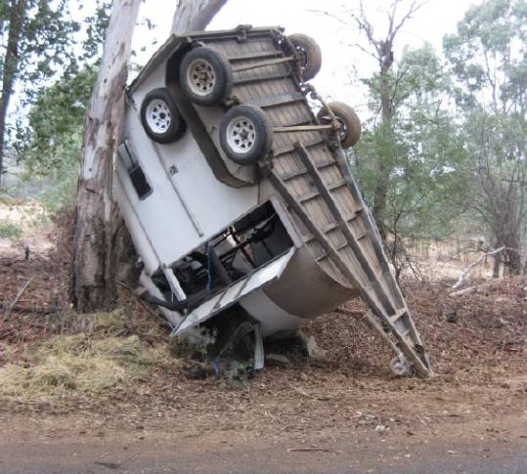
Even in the best-run horse establishments' things can go wrong or the very unexpected happens and you end up with a horse in a very difficult situation. What can you do? Well as in most risk minimization situations, prevention is you best and first line of defence.
For example:
- Safe fences
- Good gates and entrances
- Correctly fitting rugs
- Well established routines (twice daily checks)
- Horses that are used to being handled and have good ground manners
- Pre-floating checks before traveling
- Wearing hi-vis when riding on roads and trails
- A list (on your phone on the tack room wall) of emergency contact numbers.
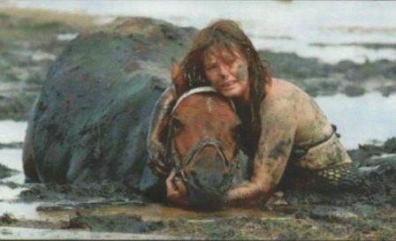
Horses are flight animal and that very instinct can land them in even greater difficulties. A poor decision can end up as a serious rescue and some situations could just not be anticipated. Horses in a dangerous or stressful situation can react unpredictably so it is vital to keep yourself safe. Some horses are reassured when a person appears and others start to panic. The aim is minimize harm and keep yourself safe.

If it is safe, check the horse's vital signs:
- Airway - nothing blocking his nostrils or mouth
- Breathing - normal respiration is c.12 beats per minute and under stress this is likely to be higher
- Circulation - if safe place your fingers on the facial artery that runs along the inside of the jawbone (it's about as thick as a pencil). The normal pulse is 35-40 beats per minute. An increased pulse suggests blood loss, shock or pain. A low pulse rate could also mean shock or hypothermia.

You also need to assess the situation - it may look utterly shocking and be
beyond comprehension but the horse maybe OK in terms of vital signs, so it
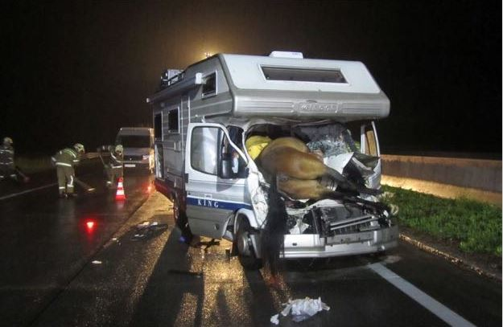
is important to triage the horse:
- Life threatening - needs appropriate treatment in the next 30 to 60 minutes. This could be due to significant blood loss or breathing difficulties. This could also mean euthanasia if the horse is beyond saving or very close to death.
- Urgent - if the horse is left untreated for more than an hour it could be come life threatening e.g. wounds or fractures.
- Not urgent - superficial type of wounds.

In some emergencies the horse can appear to have lost a lot of blood. The average horse has 50l of blood can easily lost 10% without any detrimental effect. Horses also have very effective spleens that work hard at replacing blood loss so anything under 10% (5l) is not likely to be life threatening.

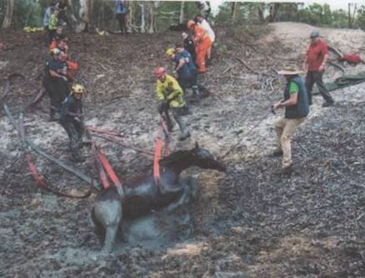
Apart from struggling in a trapped situation, the other factor is that the horse is not designed to spend very much of their time lying down (recumbent). Horses will do this when very relaxed or as a foal for a few hours a day. They are not designed to endure more than a few hours in a lying down position. So it may not be the situation that compromises the horse's health but the physical position he has been put in for the last few hours. Owners need to be prepared for this; as in that the recovery operation may be a success but the horse may need to be put down not long afterwards.

A full-blown recovery team is usually appropriately equipped to cope with a variety of situations. However, the majority of horse owners will need to improvise with every-day equipment that will not harm them or the horse in order to initiate the rescue.



For more information on Large Animal Rescue Courses please contact The West Australian Horse Council 08 9293 3577 or visit their website www.wahorsecouncil.com.au



