2018

EVENTING
TECHNICAL DELEGATE
Open Book Assignment

Pony Club WA Eventing Technical Delegate - Open Book Assignment

This assignment should be completed when requested by the Eventing Technical Delegate Coordinator, by Trainee Technical Delegates wishing to complete their accreditations.
The assignment should be completed with reference to the following documents
Current Pony Club WA Eventing Rules
Responsibilities of CD
EA National Eventing Rules
FEI Eventing Rules
EA Guide for Cross Country Course Designers and Officials
FEI Cross-Country Course Design Guide for all Officials
The completed assignment should be sent to the Pony Club WA State Eventing Committee for marking and approval via eventing@ponyclubwa.asn.au

All trainees should attempt each question to the best of their ability.

This test is worth: 50 points (1 point per question)

- What process would you follow to determine the outcome of a rider protesting the following: What would you do to determine a rider protesting:
  - 20 penalties

  - His time penalties after being held

- What is the maximum height and spread for a cross country fence for the following:
Class | Max Height | Max Spread
PC80
PC95
PC105
PC1*

- What is the process required when a rider falls on the cross country and wishes to ride a second horse in the competition?

- What is the requirement relating to flagging of Showjumping practice fences?

- The Gear Checker notices a horse has wet blood in its nostrils, and eliminates the horse from the competition. Would you support this decision?

- The showjumping course has a large number of spreads, but the Club has no breakaway cups, and has used a mixture of normal cups and flat cups for the spreads. What would you do?

- What do you do if the cross-country course has been designed and built by a non-accredited CD?

- What are the requirements regarding use of back protectors for cross country?

- What are the minimum jump requirements in a show jump practice arena?

- The weather overnight has turned to heavy rain. What considerations need to be taken into account for the cross-country phase?

- What are the rules relating to rider's use of a whip in dressage?

- After jumping the last cross-country fence, the rider brings the horse to a walk, and walks to the finish line. What should the time-keeper do?

- How would you handle a situation where a rider jumped an unflagged obstacle on the cross country course?

- What would you do if a parent of a rider competing in the competition walked the cross-country course prior to it being opened and then made suggestions to the organiser in relation to the obstacles, which may have been for the benefit of their rider?

- What is the penalty for a fall off a horse on cross country at PC95 level?

- What is the maximum height and spread for a PC95 showjumping fence?

- During the competition, a rider’s coach is in the warm-up area with the rider. Is this permissible?
Why?

- What is the maximum depth of a cross-country ditch permissible for:
  - PC80

  - PC95

  - PC105

- Where should the cross-country judges be positioned?

- What is the minimum size for an outside outdoor showjumping arena?

- A rider can change his mind when approaching a fence or element until the very last moment. Are there any exceptions?

- In the Dressage phase, a competitor is wearing spurs with rowels. Is this permitted?

- A horse slips between elements of a multiple obstacle on the cross-country course and its quarters touch the ground, but the rider does not fall off. What penalties do they incur?

- An obstacle on the cross-country course has been broken and not yet rebuilt. The jump judge waves a red flag in front of an oncoming rider and calls for him to stop. The rider considers that the fence is clear and ignores the Official. What penalties should the rider incur?

- While jumping an A/B combination, a rider's helmet comes unfastened while jumping obstacle A. Immediately after jumping obstacle B, the rider stops and refastens their helmet. What penalties should the rider receive?

- When can a rider ask a jump judge a question in the middle of a cross-country course?

- After the first class has completed the cross-country phase, the scorers tell the organiser that there are no results for Jump 13, subsequent investigations show that there was no Jump Judge for the entire class. What do you do?

- At what point would you determine that a course does not sufficiently meet the specifications for it to be accepted as a qualifying course? What actions would you take?

- At what height would you consider a jumping effort on the cross-country course to be “significant”?

- Where the official Pony Club Eventing Rule Book does not cover a specific circumstance for Eventing, what references and principles would you use to decide?

- In the case of a competitor being reported to you by the Showjumping Judge as being 'incompetent' and 'dangerous' after being eliminated in this phase. What arrangements will you make for the cross-country phase later that afternoon?

- If the ambulance leaves the ground, what steps would you take to ensure the event can continue? would you do to continue the event?

- When a Marshall is checking saddlery before the dressage test, the rider asks him not to check the bridle and bit. Is this permissible?

- A horse falls during the cross-country phase and breaks a leg - are there any circumstances in which you might be required to decide on the horse's future?

- A rider travelling at excessive speed and calls off a competitor in front of him/her at a jump. The leading competitor circles, resulting in a 2 seconds time penalty. He puts in an official objection. What will you do about the faster rider?
Describe your position on this and your decision.

- Are there any occasions when reported 'unauthorised' assistance would not result in you eliminating the competitor? Provide examples.

- A fence on the cross-country course has a roof or arch over the fence. What is the minimum recommended measurement to the roof or arch from the top of the fence?

- What is the penalty for starting the cross-country phase ahead of time?

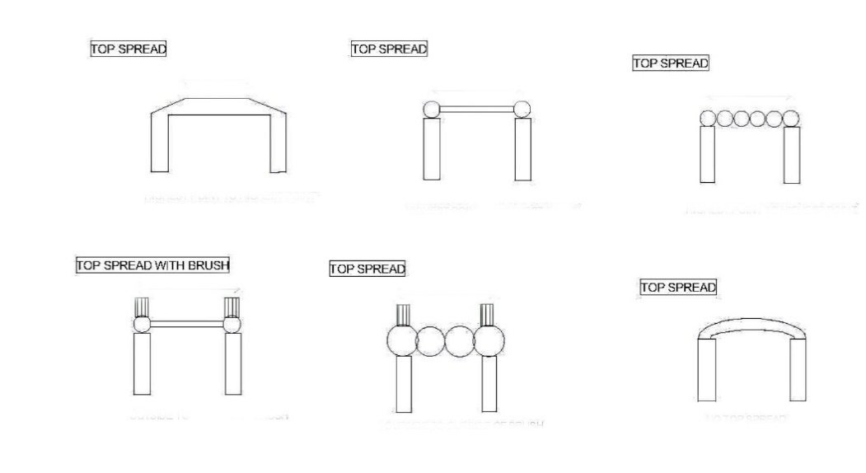
- Where would you measure the ‘spread at the top’ for the following obstacles? Please indicate.

- In what circumstances is a ‘riding down’ penalty applied?

- Can dressage tests be called, if so, for what grades/classes?

- Is a rubber snaffle permitted in the following phases:
  - Dressage

  - Cross Country

- Over the PA system, riders have been constantly reminded to keep away from the canteen area even though this is a short cut to the cross-country course. Riders are intercepted and asked to go the long way. What options are open for the following: (Be sure to support your decision with reference to the Rule Book)
  - A rider who is downright rude to an Official

  - A rider who is pleasant but re-offends with a second horse

  - A rider who was genuinely unaware of the rule

- What is the lowest level of national class at which double bridles may be used?

- A rider claims his horse has had an eye operation. The vet has certified that the horse is fit to compete in a One Day Event. Will you allow a fly shield?

- A Dressage Judge reports a horse in PC95 for being 'lame'. What criteria would influence your decision to eliminate or allow this competitor to continue?

- The competitor complains that the Dressage Judge did not allow him to complete the test for being lame. The even Vet says that the horse appears to be perfectly sound on inspection and examination. What do you do?

- A horse is eliminated by the Dressage Judge for riding in a copper bit with steel rings. The rider has put in an official objection. Would you uphold this or not and under which rule(s)?

- The landing at Fence 12 deteriorates by midway through the PC95 Class - and you decide that it is now potentially dangerous.
What can you do?

Would your decision have any effect on riders who had ridden earlier?

- The last obstacle on the cross-country course measures 2cm over height in the PC1* course, which butts up to the PC105 fence.
Your options would appear to be:
  - to re-flag the fence extending it through the PC105 fence
  - to take out the fence and flag the PC105 fence in its place
  - remove the fence altogether
  - adjust the height of the original fence, build up the take off by 2 cm
What option/s would be acceptable and what option/s would be unacceptable?

End of Assignment

