2018

EVENTING
COURSE DESIGNER
Open Book Assignment

Pony Club WA Eventing Course Designer - Open Book Assignment

This assignment should be completed when requested by the Eventing Officials Coordinator, by Trainee Eventing Course Designers/Builders wishing to complete their accreditations.
The assignment should be completed with reference to the following documents
Current Pony Club WA Eventing Rules
Responsibilities of a Course Designer
EA National Eventing Rules
FEI Eventing Rules.
EA Guide for Cross Country Course Designers and Officials
FEI Course Design Guide for all FEI officials

The completed assignment should be sent to the Pony Club WA State Eventing Committee for marking and approval via eventing@ponyclubwa.asn.au

All trainees should attempt each question to the best of their ability.

This test is worth: 25 marks (1 mark per question)

All candidates are to achieve a minimum of 24 correct answers to achieve a pass.

Pony Club WA Eventing Course Designers Open Book Assignment

- Should the first fence of a cross country course be of maximum height or width, or should it be significantly under maximum height and width?
Please explain your answer.

- What type of FENCES would you NOT use for fence number one? (Please tick)
☐ Vertical
☐ Ascending Poles
☐ Log
☐ Apex
☐ Flower Box
- What is the permitted maximum depth of a cross country ditch for the following heights:
  - PC80

  - PC95

  - PC105

- Where is the height of a fence measured from?

- What is maximum allowable drop with or without obstacle for PC105?

- The weather overnight has turned to heavy rain. What considerations need to be considered for the cross-country phase?

- With a brush fence, is there a limit on the height of the solid part of the obstacle?

- On which of the following obstacles should you use flexi-flags?
☐ Water obstacles where most problems seem to occur
☐ Drop fences
☐ Apexes
☐ Narrow fences

- Where would you build a vertical fence?
☐ In the open to allow the rider to gallop to the fence and make up time
☐ On an approach to a water complex
☐ On a bend which will slow the rider down and could cost them time
Any other suggestions?

- The Course Designer sets the distance of the PC95 course at 2615 meters. What is the Optimum Time and Time Limit?
  - Optimum Time

  - Time Limit

- Where would you measure the ‘spread at the top’ for the following obstacles? (Please indicate)

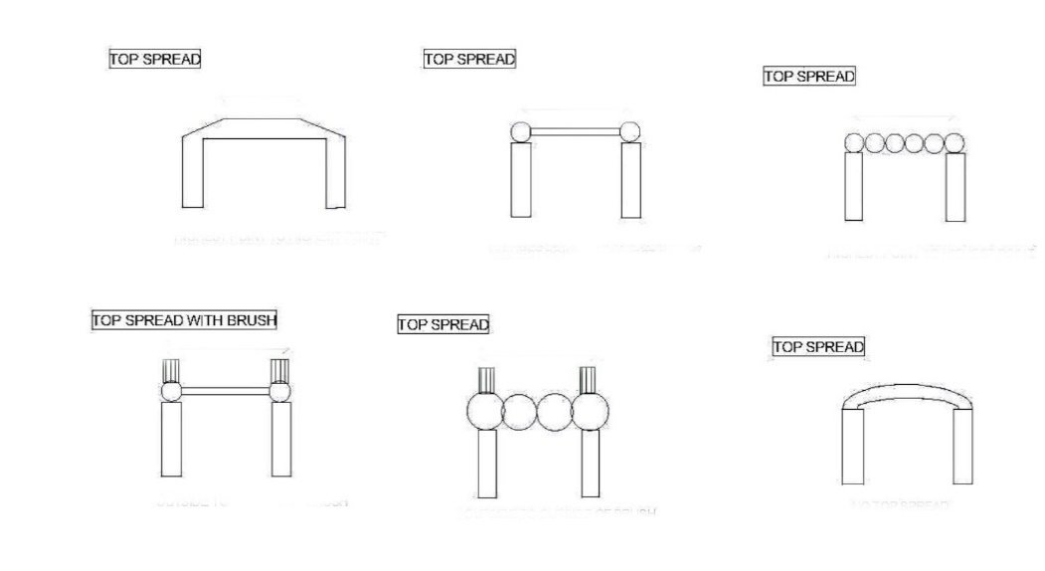
- How do you measure a drop fence with brush?

- A fence on the cross-country course has a roof or arch over the fence. What is the minimum recommended measurement to the roof or arch from the top of the fence?

- There is a jump 2 cm over height in the PC1* course, which butts up to the PC105 fence. What are your options? (Please tick the appropriate boxes)
☐ To re-flag the fence extending it through the PC105 fence.
☐ To take out the fence and flag the PC105 fence in its place.
☐ Remove the PC1* fence altogether.
☐ Adjust the height of the original fence
☐ Build up the take off by 2 cm

- Under the rules all portable fences must be secured in such a way that the fence cannot be moved? Please indicate the safest method from the list below.
☐ Timber Posts
☐ Star Pickets
☐ Spirafix Pegs
State any Other

- Where is the base spread of a fence measured from?
☐ Inside to inside of material making up the fence.
☐ Outside to outside of material making up the fence
- A water fence with a uniform base is used for all grades. What is the maximum depth of the water for:
- PC105

- PC95

- PC45?

- What is the minimum length of a Water Crossing?

- What is the minimum length of a Water crossing when jumping out of water?

- An Apex is numbered 7AB with Black Stripes on flags.
- How many alternative obstacles must be provided?

- What number and letters must be on the alternative fences?

- Do alternative Flags require black stripes?

- What is the maximum allowable drop into water for PC80?

- Does the course designer have to be present when the TD is inspecting the course?
  - Yes or No (If answer is no a reason must be provided)

- As a very minimum, where would you place the anchor pins on a portable fence
☐ Front
☐ Back
☐ One back corner and diagonal front corner

- How would you secure a portable seat fence with a height of 1.05 m and a base of 70 cm
☐ Spirafix ground anchors
☐ Timber posts
☐ Star pickets
Any other option?

- When building a combination fence, what should you consider?

End of Assignment

